**Termwork 1**

NAME: XXX DATE: 20/04/2023

USN: 2GI20CSXXX

**Path Found Example:**

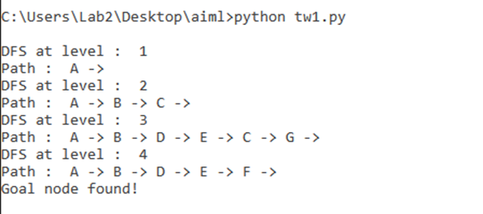

**Path Not Found Example:**

